St Laurence Church, Blackmore
Gift Aid Declaration

If you are a UK taxpayer and eligible to Gift Aid your donation, please complete the declaration below. This will increase your gift by 25p for every £1 given at no extra cost to you or us.
Thank you.

Please treat as Gift Aid donations all qualifying gifts of money made to Blackmore PCC from the date of this declaration and in the past four years.
I am a UK taxpayer and understand that if I pay less Income Tax and/or Capital Gains Tax than the amount of Gift Aid claimed on all my donations in that tax year it is my responsibility to pay any difference.

Full Name: ___________________________________________________________________
Address: ____________________________________________________________________
____________________________________________________________________________
_____________________________________________ Postcode: _____________________
Signature: ____________________________________ Date: ________________________
Email (optional): ______________________________________________________________
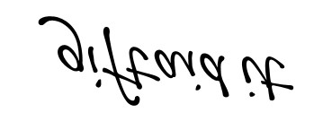
NOTES
- Please notify the church / PCC if you:
- Want to cancel this declaration
- Change your name or home address
- No longer pay sufficient tax on your income and/or capital gains
Gift Aid is linked to basic rate tax which allows charities to reclaim 25p for every £1 donated.
- If you pay Income Tax at the higher or additional rate and want to receive the additional tax relief due to you, you must include all your Gift Aid donations on your Self-Assessment tax return or ask HM Revenue and Customs to adjust your tax code.
Please complete this form and either:
Post to: The Treasurer, or scan and email to:
Corfu, Blackmore Road,
Blackmore, blackmorechurchft@gmail.com
Ingatestone,
CM4 0QX

Privacy Notice: This form is held by the Treasurer and only used for the purpose of claiming Gift Aid.

